Week 06 Assignment
Step 1: Create Spark Environment and Understand Spark Architecture
Objective
To initialize Apache Spark using PySpark, understand the Spark Architecture, and verify that the Spark environment is working correctly.
Components
1. Driver Program
The Driver is the main program of the Spark application. It creates the Spark Session, converts user code into jobs, schedules tasks, and collects the final results from executors.
2. Cluster Manager
The Cluster Manager is responsible for allocating CPU, memory, and other resources to the Spark application. Examples include Standalone, Hadoop YARN, and Kubernetes.
3. Executors
Executors are worker processes that perform the actual data processing. They execute tasks assigned by the Driver and return the results.
Apache Spark Architecture
Apache Spark follows a distributed architecture where the Driver Program coordinates the entire application. The Cluster Manager allocates computing resources, while Executors perform parallel data processing tasks. This architecture enables Spark to process large datasets efficiently and fault-tolerantly.

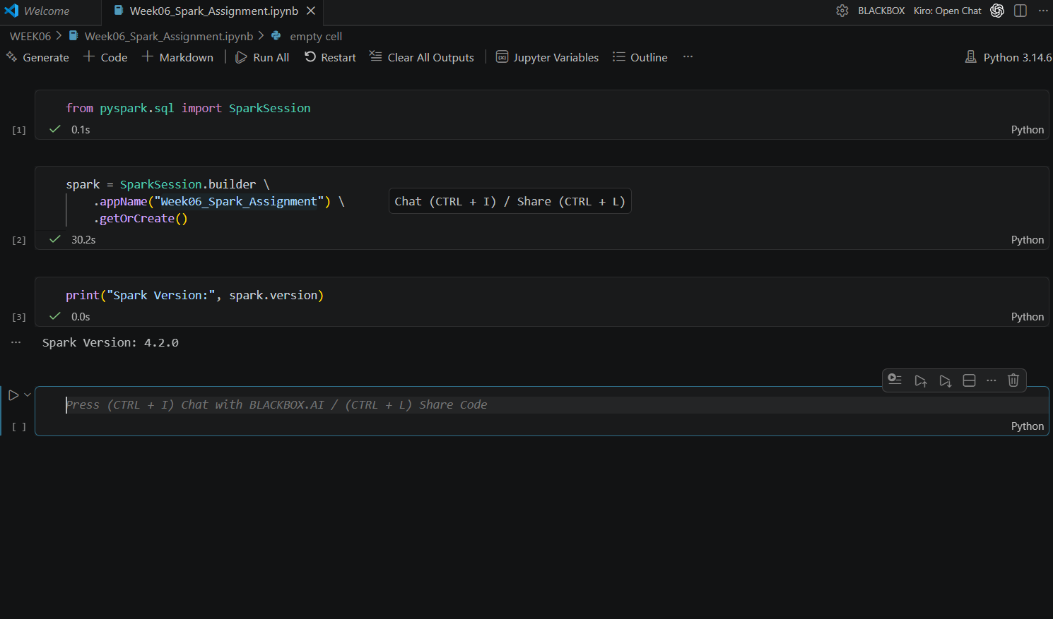
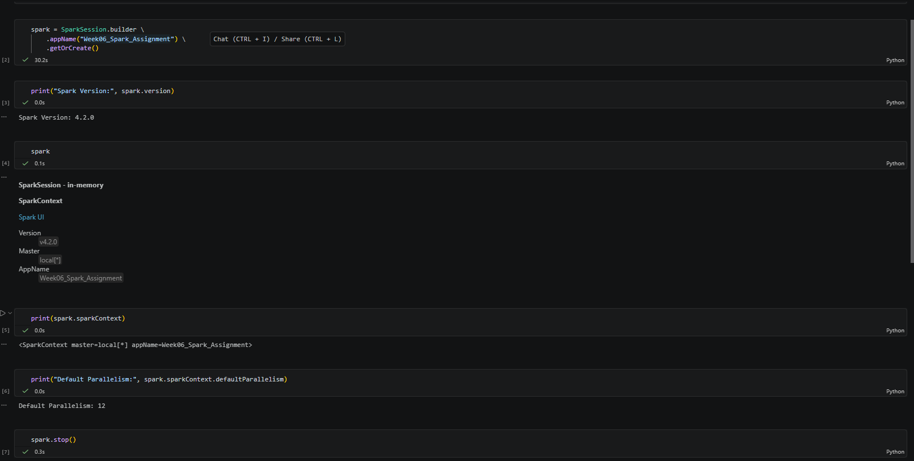

Step 02 Reading CSV Data with Schema Handling
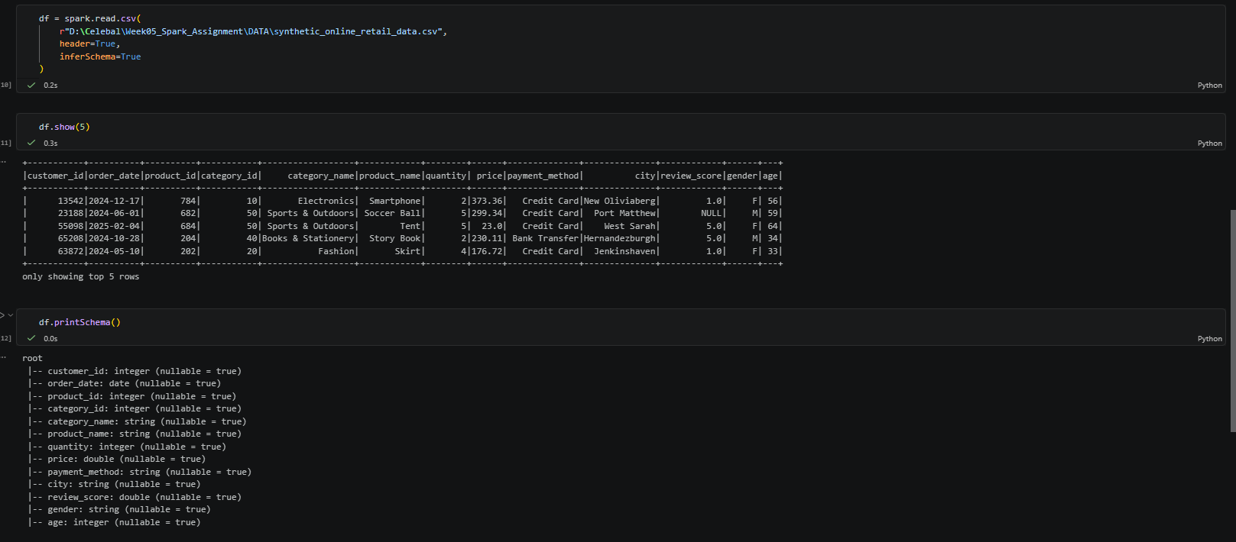

Step 03 Reading CSV Data with Schema Handling
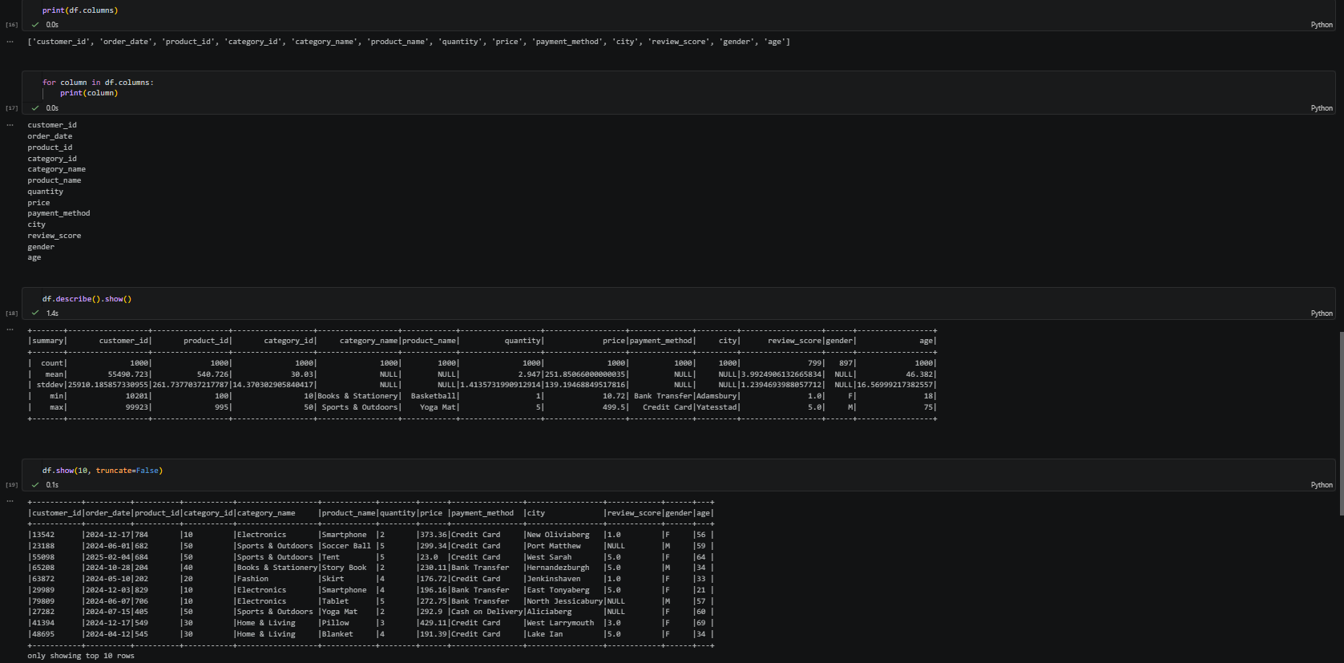

Step 04
- Select Product ID and Price Where Category is Electronics
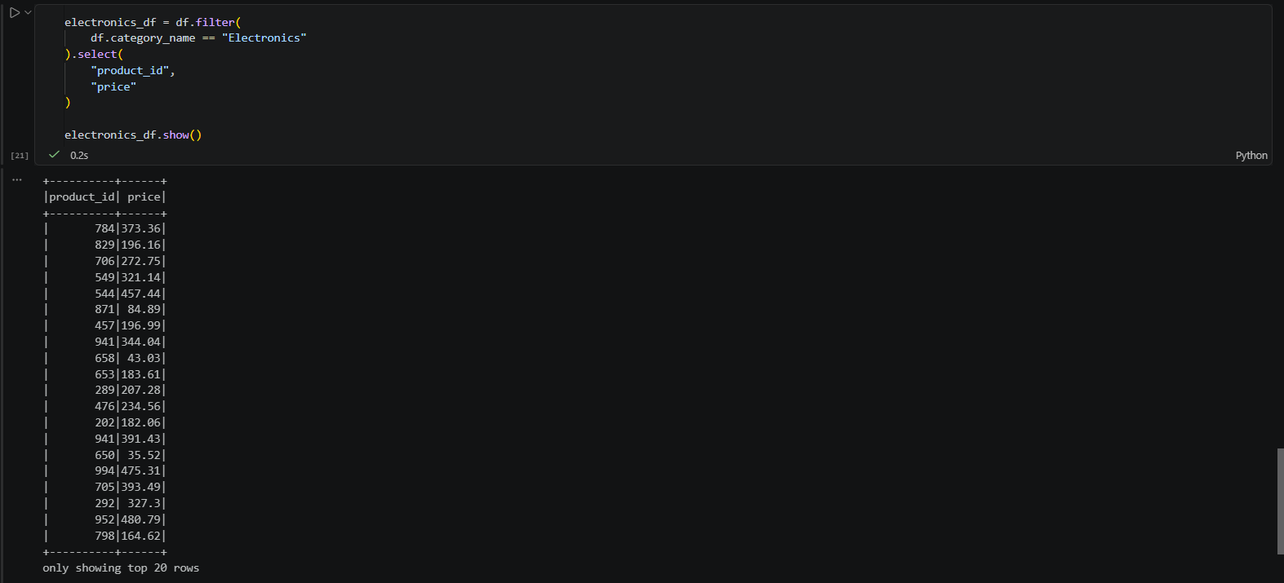
- Filter Electronics Products Costing More Than 200
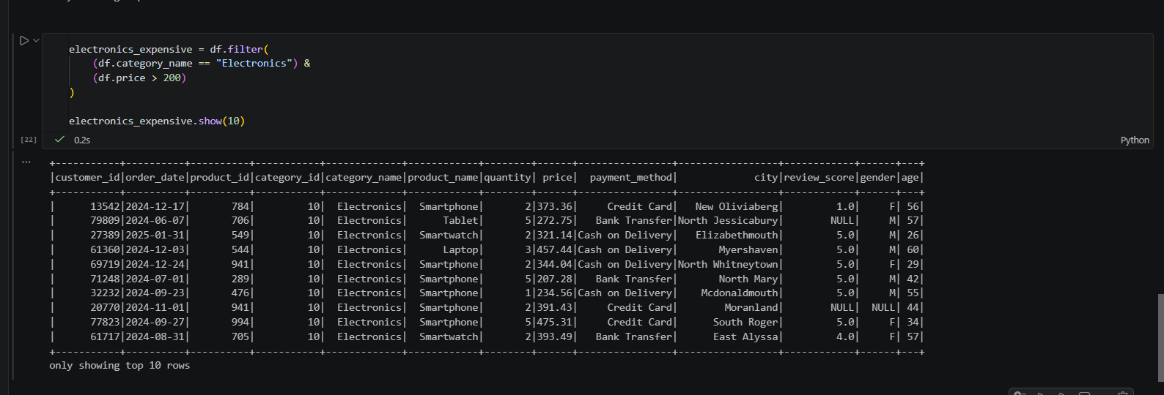
- Multiple Conditions (AND)
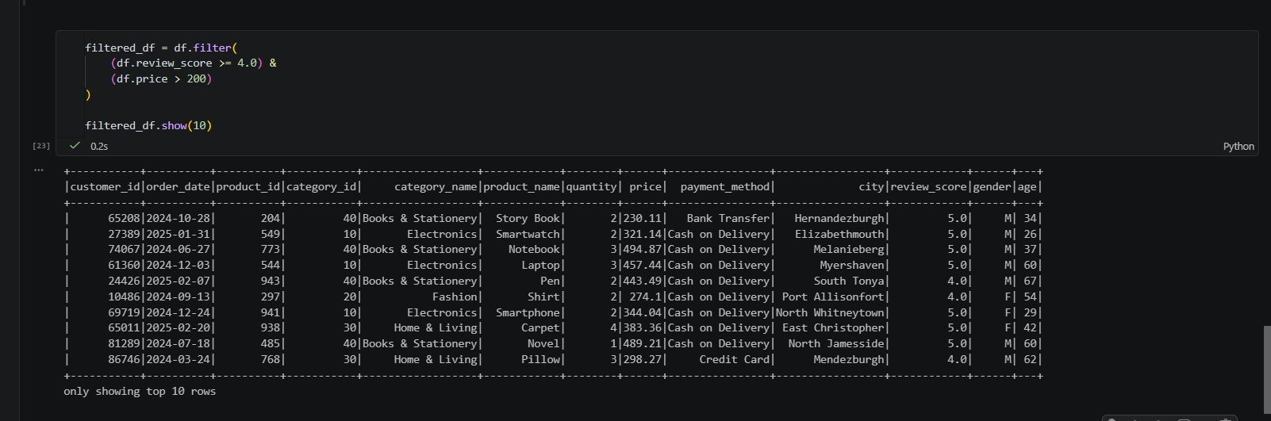
- Multiple Conditions (OR)
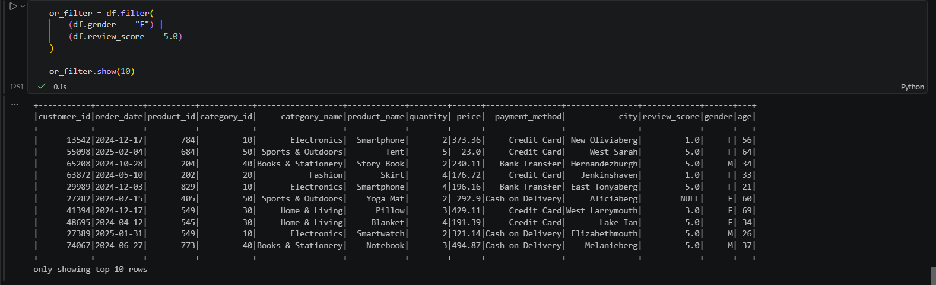
- Selecting Multiple Columns
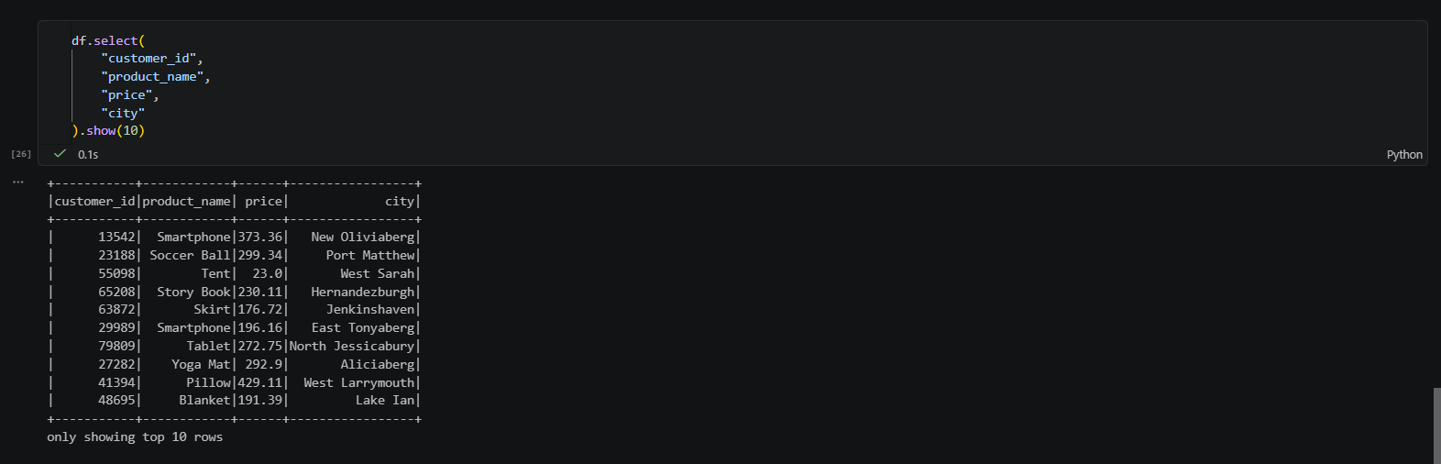

Step 05
1 Rename a Column (Q6)
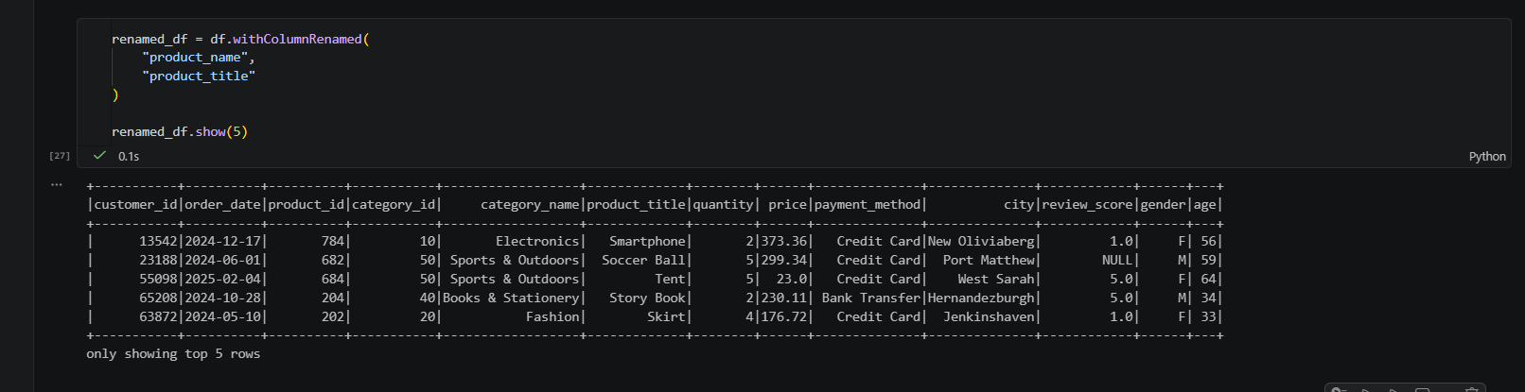
2. Cast the Price Column (Q6)
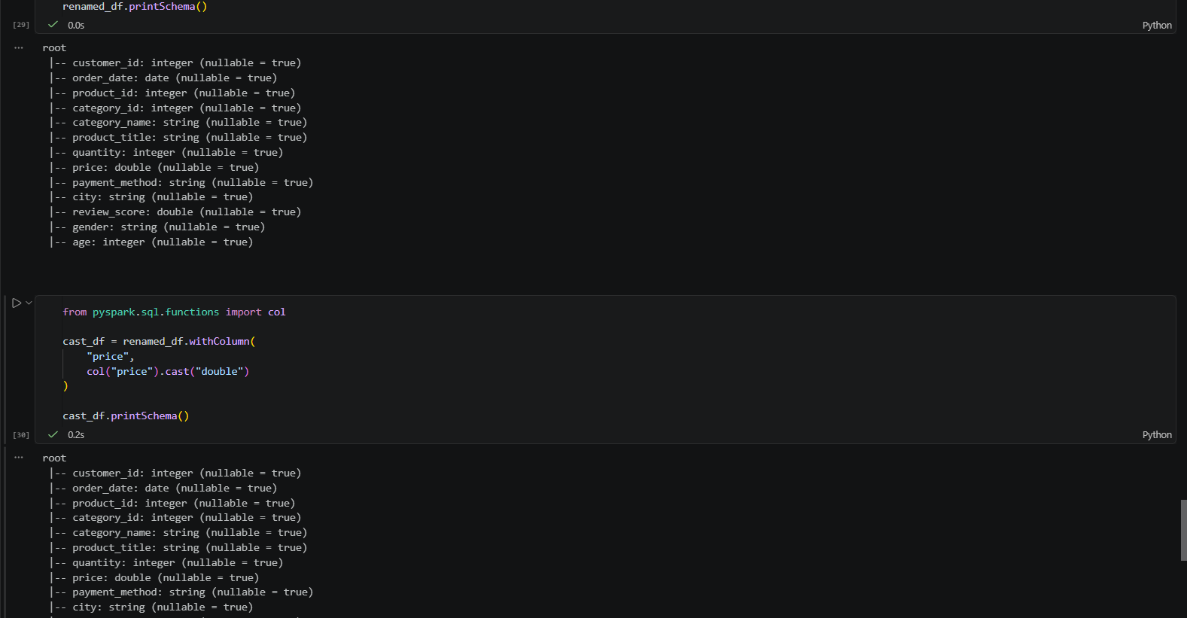 3. Add a New Column (Q10)
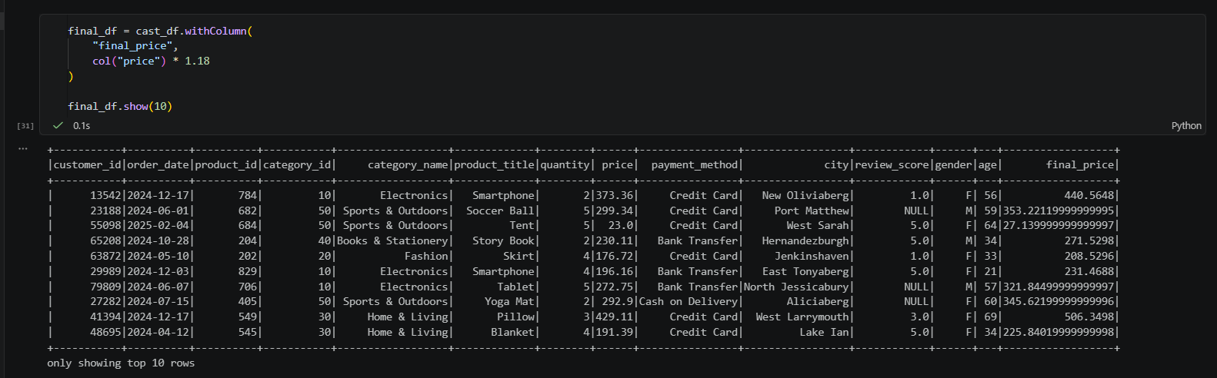

4. Round the Final Price
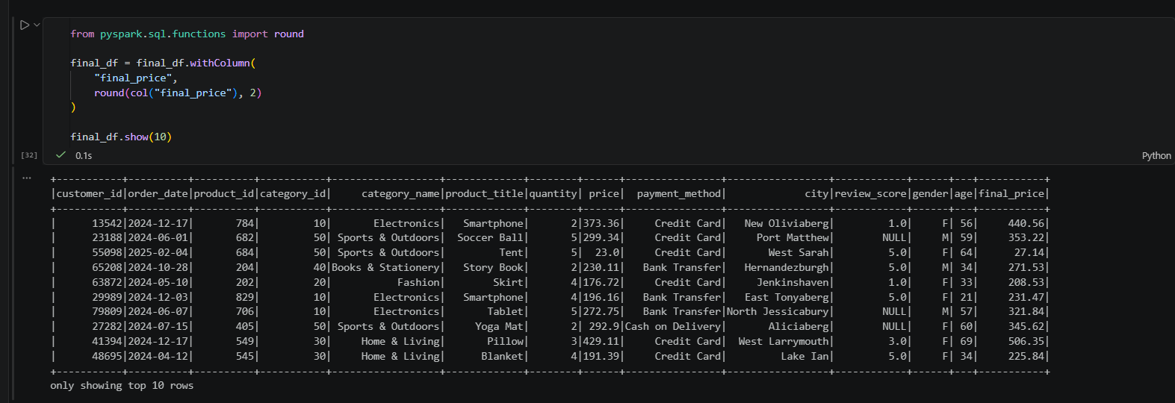

- Display Selected Columns
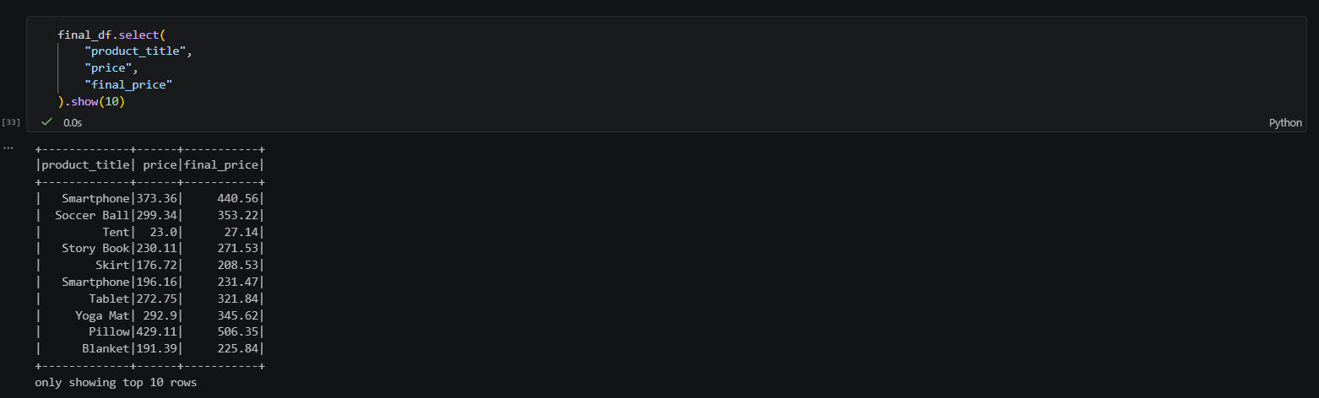

Step 06 Transformations, Actions, and Null Handling
What is a Transformation?
A Transformation creates a new DataFrame from an existing one. It does not execute immediately because Spark uses Lazy Evaluation.
Common Transformations
- select()
- filter()
- withColumn()
- withColumnRenamed()
- drop()
- groupBy()

What is an Action?
An Action triggers the execution of all pending transformations and returns a result or writes data.
Common Actions
- show()
- count()
- collect()
- first()
- take()
- write()
- Apply a Transformation
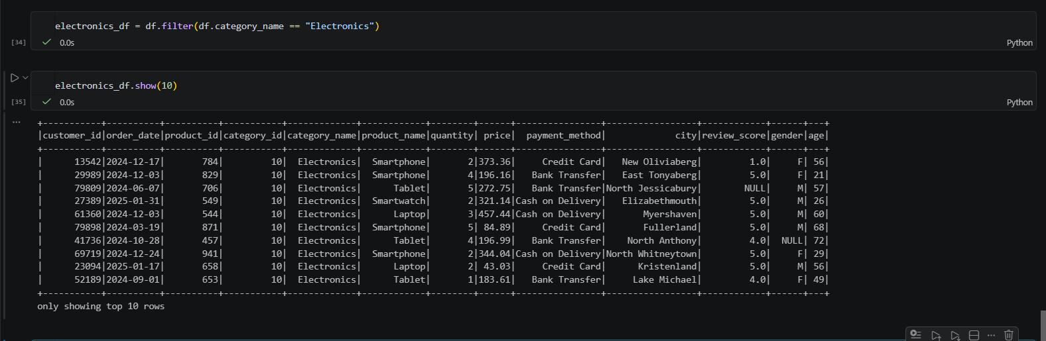
- Another Action
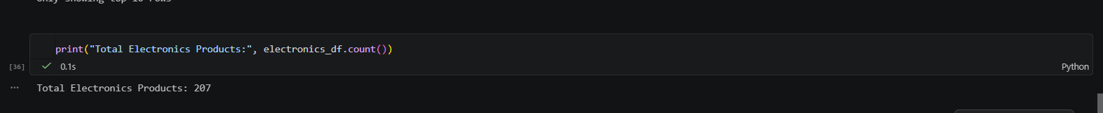
- Find Null Values
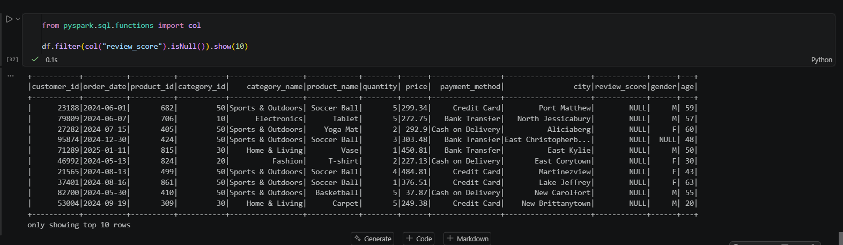

- Count Null Values
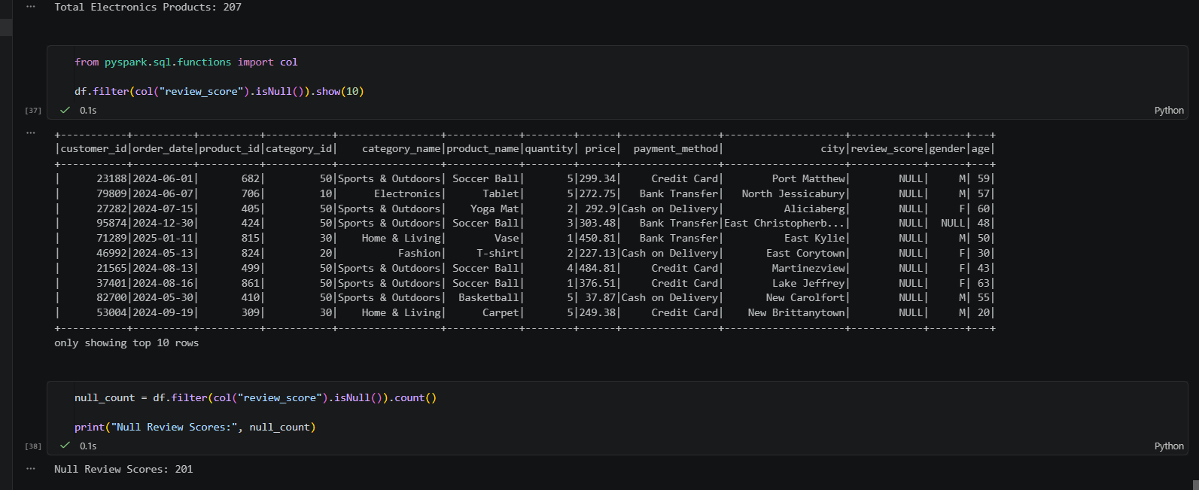
- Remove Null Values
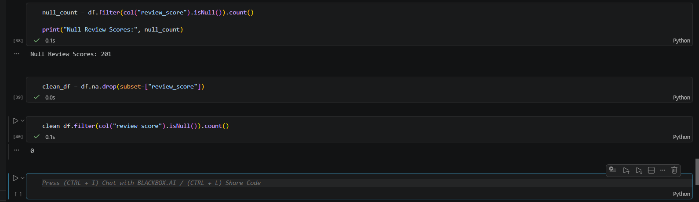
- Performance Best Practices
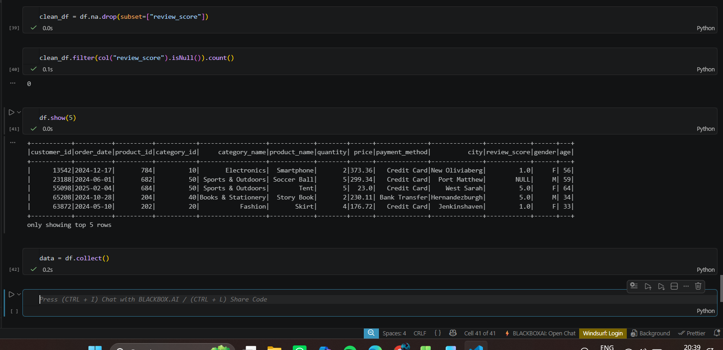

Step 07 Build a Complete Data Pipeline
1 . Create the Final DataFrame
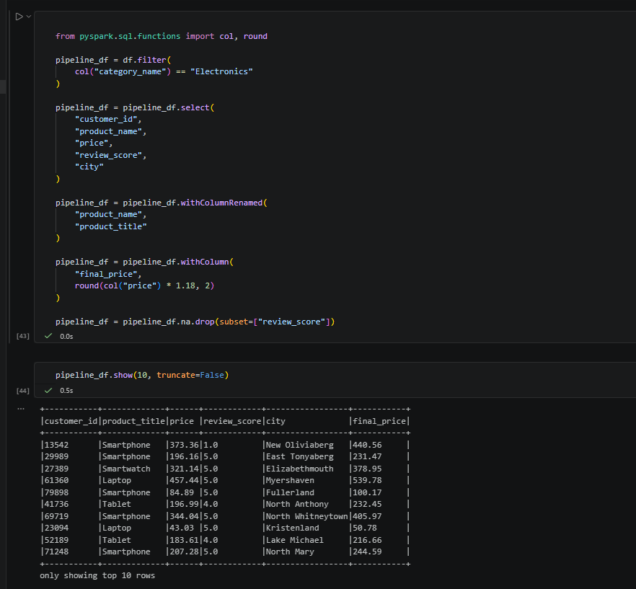

Step 8 – Spark Architecture
1. Driver
The Driver is the main program of a Spark application.
Responsibilities:
- Creates the SparkSession.
- Converts your code into execution tasks.
- Creates the DAG (Directed Acyclic Graph).
- Schedules tasks to Executors.
- Collects results from Executors.

2. Cluster Manager
The Cluster Manager manages the cluster resources.
Its job is to:
- Allocate CPU and memory.
- Launch Executor processes.
- Manage resources efficiently.
Examples:
- Standalone Cluster Manager
- YARN
- Kubernetes
- Apache Mesos
3. Executor
Executors are worker processes that perform the actual computations.
They:
- Execute tasks assigned by the Driver.
- Store intermediate data.
- Return results to the Driver.
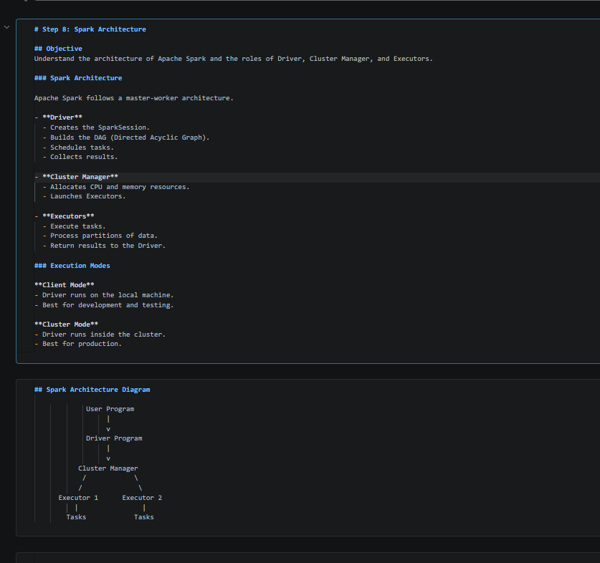

Step 09 Lazy Evaluation & DAG (Lineage Graph)

  - Create Transformations
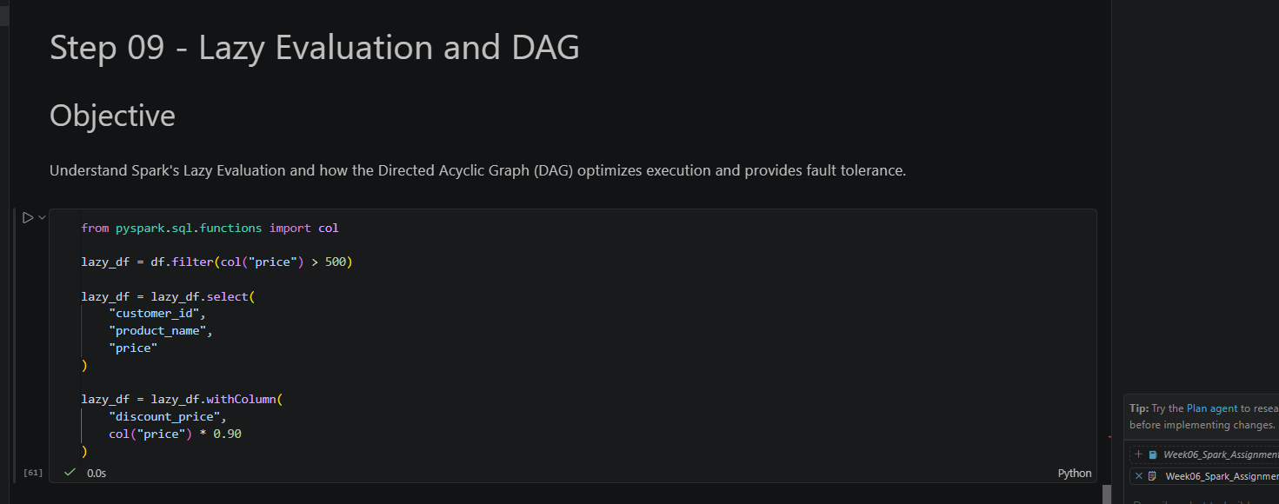
  - Execute an Action
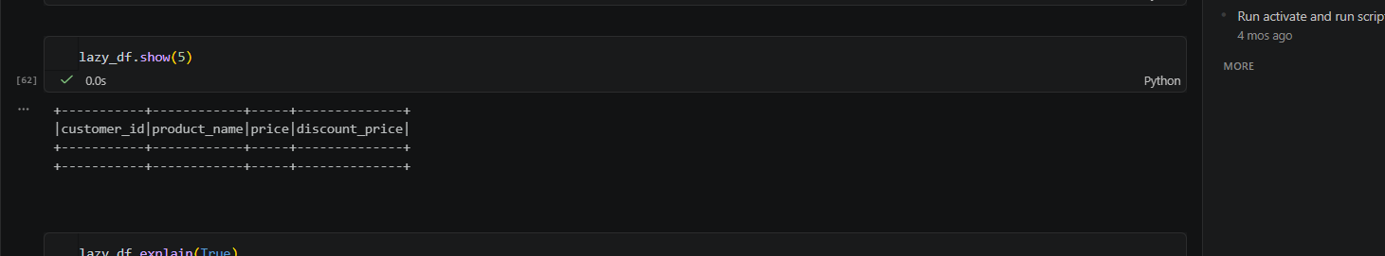
  - View the Execution Plan (DAG)
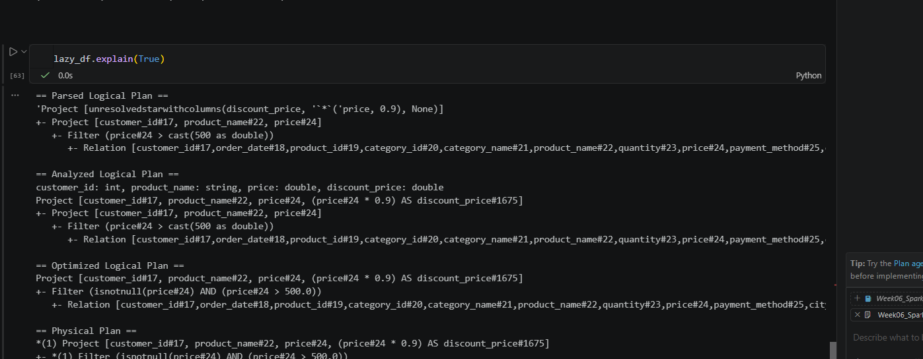
STEP 10 – CSV vs Parquet & Predicate Pushdown
  - Read CSV
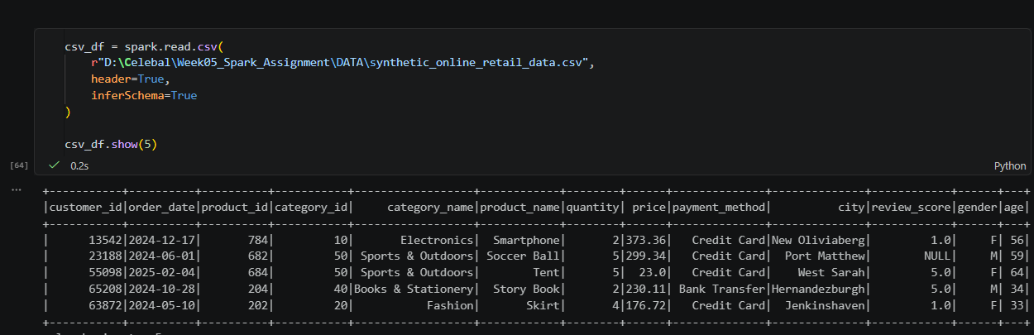
  - Simulate Predicate Pushdown
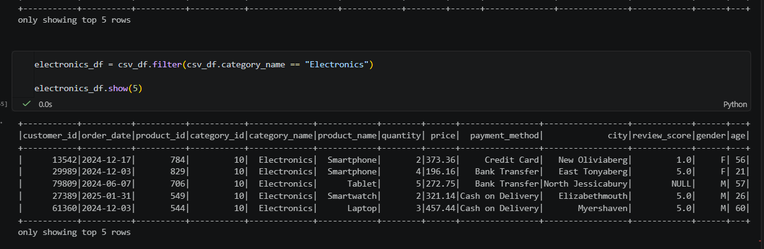
  - Count Filtered Rows
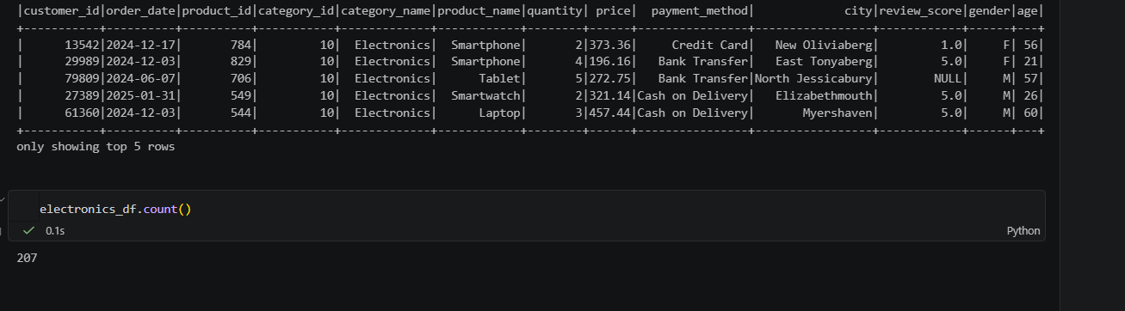

STEP 11 – Transformations vs Actions & show() vs collect()
- Demonstrate a Transformation
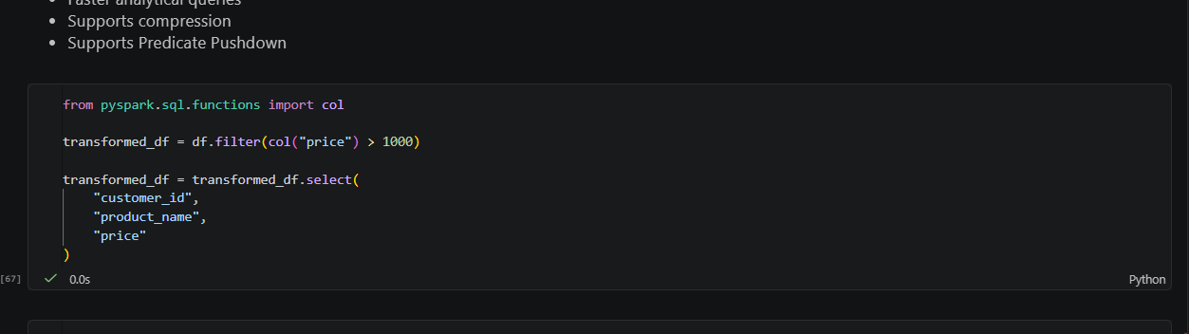
- Demonstrate an Action
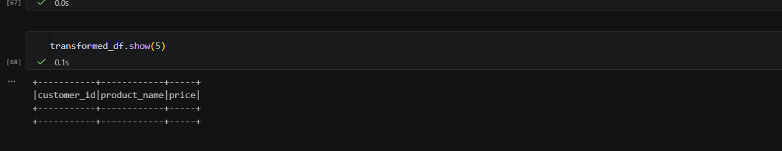
- Another Action
